- fix.html
<!DOCTYPE html>
<html>
<body>
<script>
alert( "I’m JavaScript!");
</script>
Whats the error in this ?
</body>
</html>

Reason:
Here the alert message is closed with single quote
alert( "I’m JavaScript!"); //will work perfectly.

- fix.html
<!DOCTYPE html>
<html>
<body>
<script src=”script.js”></script>
</body>
</html>
scripts.js
alert(“I’m invoked!”);

Reason:
Invalid double quotation used.
Changing it to src="script.js" and alert("I’m invoked!");
Will work.

- Explain the below how it works

explain.html

<!DOCTYPE html>
<html>
<body>
<script src=”script.js”></script>
</body>
</html>

script.js

alert("I'm JavaScript!");
alert('Hello') // this line is not having semicolon
alert(`Wor
ld`)
alert(3 +
1
+ 2); // this is multiple line code and its working

Explanation:

alert("I'm JavaScript!"); -- There are no errors in this line and it will work fine and display the message

alert('Hello') --- Semicolon is optional so it will display the Hello message.

alert(`Wor
ld`) --- There are no errors here Wor will be printed in one line and ld in next line.

alert(3 +
1
+ 2); --- It will display the result 6 by adding the numbers.

Fix the below to alert Guvi geek

fix.html

<!DOCTYPE html>
<html>
<body>
<script src="script.js"></script>
</body>
</html>

script.js

let admin=9, fname=10.5;
fname = "Guvi";
lname = "geek"
admin = fname+' '+lname; //add space by using template literals
alert( admin ); // "Guvi geek"

Output:
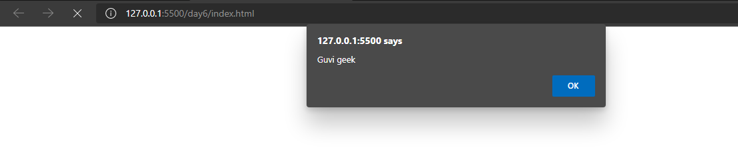

Fix the below to alert hello Guvi geek

fix.html

<!DOCTYPE html>
<html>
<body>
<script src="script.js"></script>
</body>
</html>

script.js

let fname=10.5;
fname = "Guvi";
lname = "geek"
let name = fname+' '+lname;
alert( `hello ${name}` ); //we have to use tilde operator if we want to dispay value using $

Output:

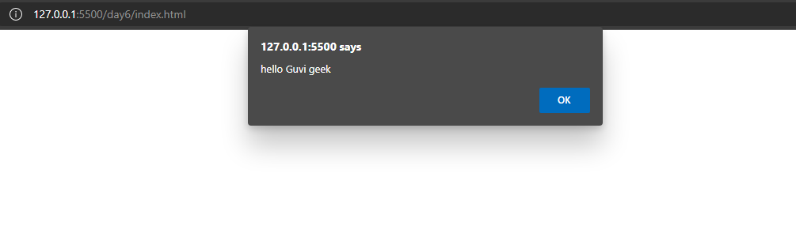

Fix the below to alert sum of two numbers

Fix.html

<!DOCTYPE html>
<html>
<body>
<script src="script.js"></script>
</body>
</html>

script.js

let a = parseInt(prompt("First number?"));//using parseInt convert it into integer
let b = parseInt(prompt("Second number?"));
alert(a + b);

Output:
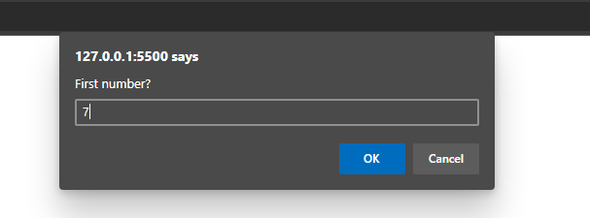
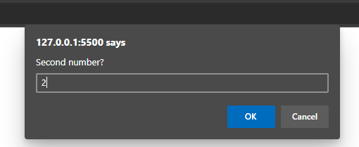
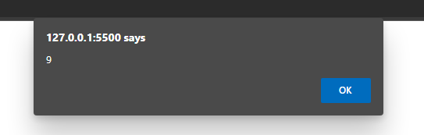

If you run the below scritpt you will get “Code is Blasted”
Explain Why the Code is blasted and how to diffuse it and get “Diffused”.

Fix.html

<!DOCTYPE html>
<html>
<body>
<script src="script.js"></script>
</body>
</html>

script.js

var a = 2 > 12; //Remove the double quotes
//Don't touch below this
if (a) {
console.log("Code is Blasted")
}
else
{
console.log("Diffused")
}

Output:
PS C:\Users\chris\desktop\b27\day6> node script.js
Diffused

How to get the success in console.

fix.html
<!DOCTYPE html>
<html>
<body>
<script src=”script.js”></script>
</body>
</html>

script.js

let a = parseInt(prompt("Enter a number?"));

//Don't modify any code below this
if (a) {
console.log( 'OMG it works for any number inc 0' );
}
else
{
console.log( "Success" );
}

Solution:

“Success can be achieved by giving the input ‘0’in alert message, since 0(zero) means false, it will print Success.

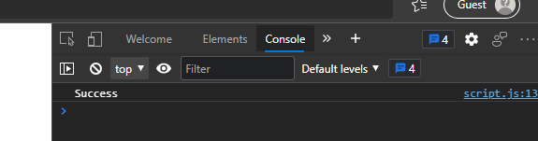

How to get the correct score in console.
fix.html
<!DOCTYPE html>
<html>
<body>
<script src=”script.js”></script>
</body>
</html>
script.js
let value = parseInt(prompt('How many runs you scored in this ball'));
if (value === 4) {
console.log("You hit a Four");
} else if (value === 6) {
console.log("You hit a Six");
} else {
console.log("I couldn't figure out");
}

Solution:
Here if give input as 4 and 6 then we will get the correct score.

Output:
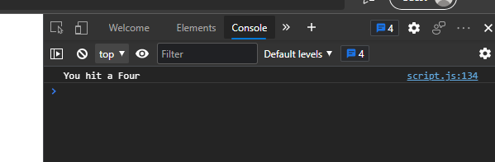

Fix the code to welcome the Employee
fix.html
<!DOCTYPE html>
<html>
<body>
<script src=”script.js”></script>
</body>
</html>

script.js
let login = 'Employee';
let message = (login == 'Employee') ? 'Employee': //After ? statement was missing
(login == 'Director') ? 'Greetings' :
(login == '') ? 'No login' :
'';
console.log(message);

Output:
PS C:\Users\chris\desktop\b27\day6> node script.js
Employee

Fix the code to welcome the boss
fix.html
<!DOCTYPE html>
<html>
<body>
<script src=”script.js”></script>
</body>
</html>
script.js
let message;
if (null || 2 || undefined )
{
message = "welcome boss"; //variable was declared multiple times
}
else
{
message = "Go away";
}
console.log(message);

Output:
PS C:\Users\chris\desktop\b27\day6> node script.js
welcome boss

Fix the code to welcome the boss
fix.html
<!DOCTYPE html>
<html>
<body>
<script src=”script.js”></script>
</body>
</html>
script.js
// You cant change the value of the msg
let message;
let lock = 0;//change lock value to zeo so that in condition it will become false
//Dont change any code below this
if (null || lock || undefined )
{
message = "Go away";
}
else
{
message = "welcome";
}
console.log(message);

Output:
If we change lock value to zero then it will print welcome.

PS C:\Users\chris\desktop\b27\day6> node script.js
Welcome

Fix the code to welcome the boss
fix.html
<!DOCTYPE html>
<html>
<body>
<script src=”script.js”></script>
</body>
</html>

script.js
let message;
let lock = 0;//change values to zero so that condition becomes false
//Dont change any code below this
if (lock && " " || undefined )
{
message = "Go away";
}
else
{
message = "welcome";
}
console.log(message);

Output:
PS C:\Users\chris\desktop\b27\day6> node script.js
Welcome

Change the code to print
3
2
1
fix.html
<!DOCTYPE html>
<html>
<body>
<script src=”script.js”></script>
</body>
</html>
script.js
let i = 3;
while (i) {
console.log( i-- );//Post increment will first print and then decrement the values
}

Output:
PS C:\Users\chris\desktop\b27\day6> node script.js
3
2
1

Change the code to print 1 to 10 in 4 lines
fix.html
<!DOCTYPE html>
<html>
<body>
<script src=”script.js”></script>
</body>
</html>

script.js
let num = 1
console.log(`${num++} ${num++} ${num++}
${num++} ${num++} ${num++}
${num++} ${num++}
${num++} ${num++}`)
//This code will print output in 4 lines

Output:

PS C:\Users\chris\desktop\b27\day6> node script.js
1 2 3
4 5 6
7 8
9 10

Change the code to print even numbers
fix.html
<!DOCTYPE html>
<html>
<body>
<script src=”script.js”></script>
</body>
</html>
script.js
for (let num = 2; num <= 20; num += 2) { //increment with 2 to get even numbers
console.log(num)
}

Output:
PS C:\Users\chris\desktop\b27\day6> node script.js
2
4
6
8
10
12
14
16
18
20

Change the code to print all the gifts

fix.html
<!DOCTYPE html>
<html>
<body>
<script src=”script.js”></script>
</body>
</html>

script.js
let gifts = ["teddy bear", "drone", "doll"];
for (let i = 0; i < 3; i++) {
console.log(`Wrapped ${gifts[i]} and added a bow!`);
}

Output:

PS C:\Users\chris\desktop\b27\day6> node script.js
Wrapped teddy bear and added a bow!
Wrapped drone and added a bow!
Wrapped doll and added a bow!

Fix the code to disarm the bomb.
fix.html
<!DOCTYPE html>
<html>
<body>
<script src=”script.js”></script>
</body>
</html>

script.js
let countdown = 100;
while (countdown > 0) {
if(countdown == 0)
{
console.log("bomb triggered");
}
Countdown--;//decrement the countdown below so that for 0 condition will be checked
}

Output:

Here bomb triggered message will not be printed

Whats the msg printed and why?

var lemein = “0”;
var lemeout = 0;
var msg = “”;if (lemein) {
msg += “hi”;
}if (lemeout) {
msg += ‘Hello’;
}console.log(msg);

Output:
PS C:\Users\chris\desktop\b27\day6> node script.js
Hi

Explanation:

var lemein = "0";
var lemeout = 0;
var msg = "";
if (lemein) { //it contains a string so anything other than 0 and false it will be true, so hi will be printed
msg += "hi";
}
if (lemeout) { //it contains number 0 which is false and body of this will not br executed
msg += "Hello";
}
console.log(msg);

Whats the msg printed and why? Guess you answer before running it.
var lemein = “0”;
var lemeout = 0;
var msg = “”;if (lemein) {
msg += “hi”;
}if (lemeout) {
msg += ‘Hello’;
}console.log(msg);

Output:
PS C:\Users\chris\desktop\b27\day6> node script.js
Hi

Explanation:

var lemein = "0";
var lemeout = 0;
var msg = "";
if (lemein) { //it contains a string so anything other than 0 and false it will be true, so hi will be printed
msg += "hi";
}
if (lemeout) { //it contains number 0 which is false and body of this will not br executed
msg += "Hello";
}
console.log(msg);

